**PCB**

Tampak belakang Double Side Tampak Depan One Side

Tampak atas

**Display**

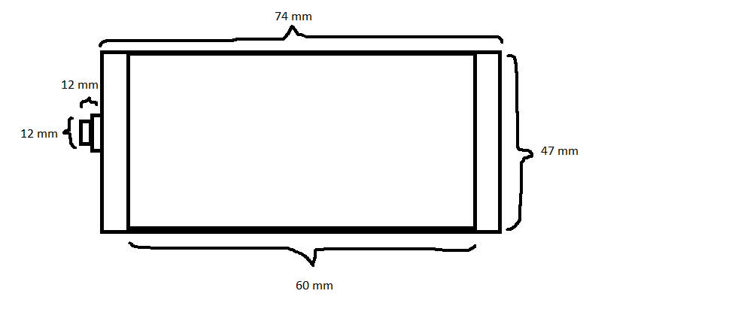

**Case**